**DAILY ONLINE ACTIVITIES SUMMARY**

|  |  |  |  |  |  |  |  |  |
| --- | --- | --- | --- | --- | --- | --- | --- | --- |
| **Date:** | **01/06/2020** | | | | | **Name:** | **Hanan Saleem Baji** | |
| **Sem & Sec** | **4th SEM 'A' Section** | | | | | **USN:** | **4AL18CS024** | |
| **Online Test Summary** | | | | | | | | |
| **Subject** | | **Maths** | | | | | | |
| **Max. Marks** | | **30** | | **Score** | | | **30** | |
| **Certification Course Summary** | | | | | | | | |
| **Course** | **1. Cyber security** | | | | | | | |
| **Certificate Provider** | | | **1. Great Learning Academy** | | **Duration** | | | **1. 3 hour** |
| **Coding Challenges** | | | | | | | | |
| **Problem Statement:** 1. Given an array of positive integers. Write a C Program to find the leaders in the array.  2. Given an array arr[] of size N and an integer K. The task is to find the count of subarrays such that each subarray has exactly K distinct elements.  .  For example | | | | | | | | |
| **Status: completed** | | | | | | | | |
| **Uploaded the report in Github** | | | | | **Yes** | | | |
| **If yes Repository name** | | | | | <https://github.com/saleemhananbaji/C-coding> | | | |
| **Uploaded the report in slack** | | | | | **Yes** | | | |

ONLINE TEST DETAILS: Online test was conducted on the fifth module of **Maths**. Test contains 10 questions of 1 mark each and 10 questions of 2 mark each. I have scored 30 Marks.

Snapshot:

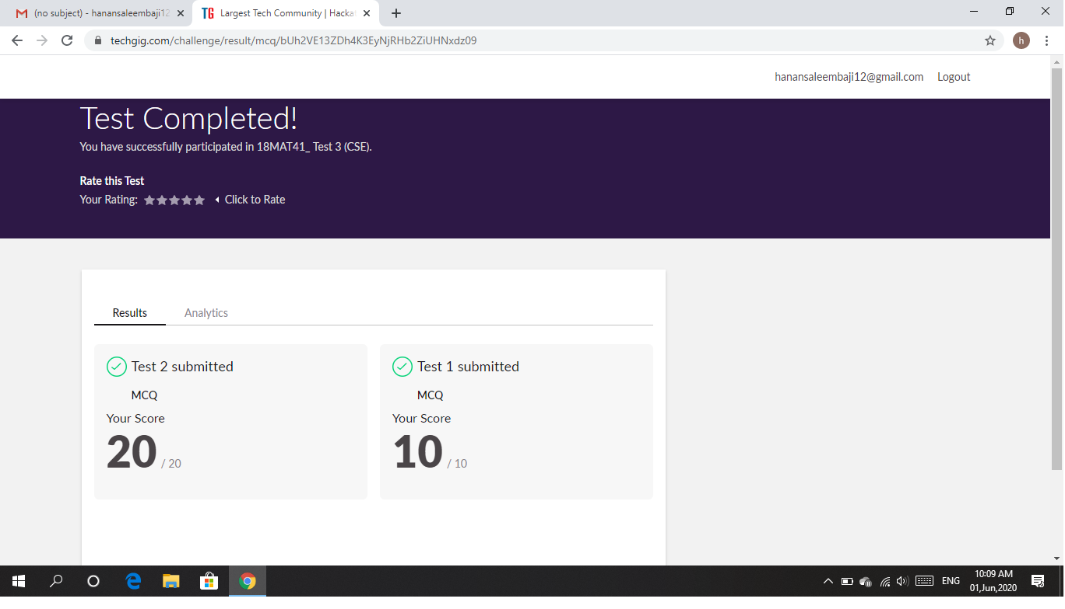

Certification Course Details: As the continuation of online course, I was able to complete the governance and risk in cyber security.

Snapshot:

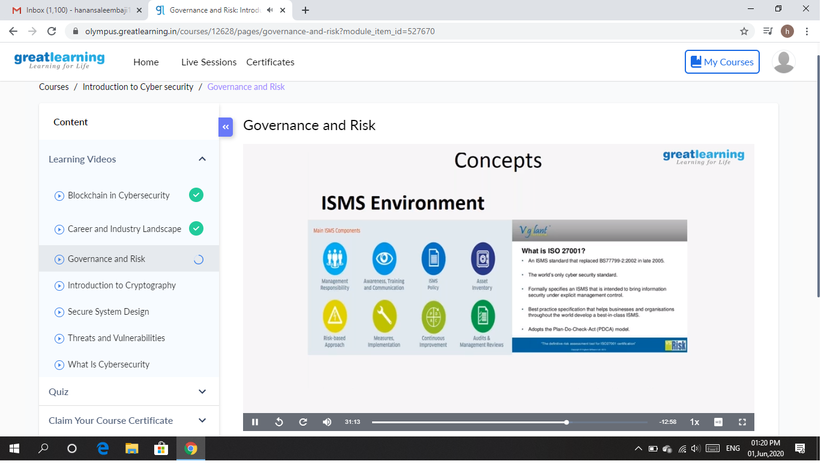

CODING CHALLENGES DETAILS: Problem statements

1. Given an array of positive integers. Write a C Program to find the leaders in the array.

Solution: Uploaded it in github

Snapshot:

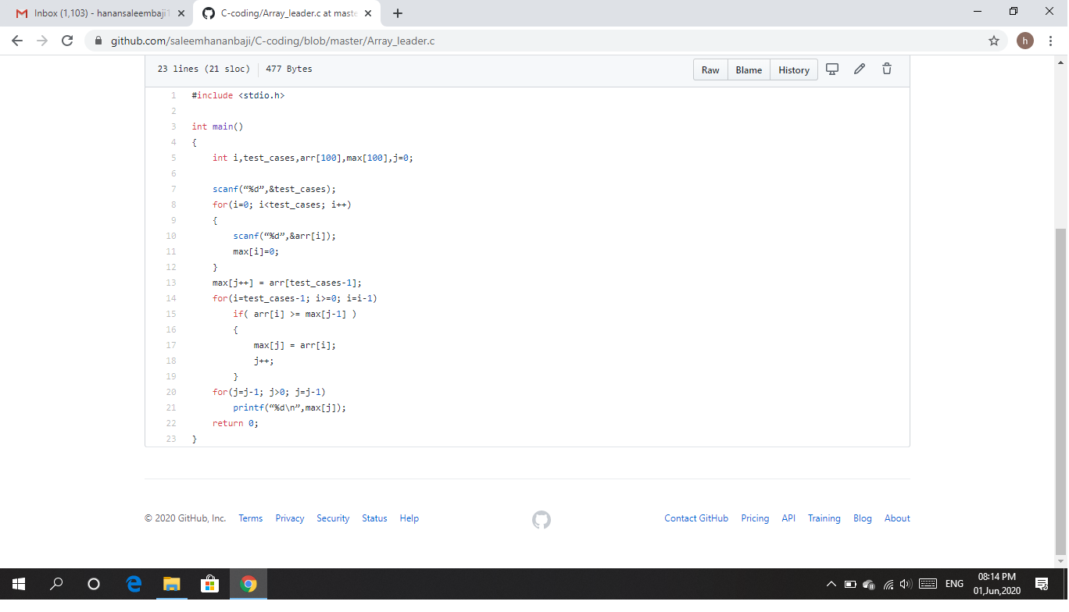

1. Given an array arr[] of size N and an integer K. The task is to find the count of subarrays such that each subarray has exactly K distinct elements.

Solution: Uploaded it in github

Snapshot:

